ENGR 325 Final Lab Design Project Proposal

Raspberry Pi controller for Conveyor Belt

Robert Akinie, Heon Soo Park

ENGR 325-L

November 13, 2020

Project Overview:

The overall project that this team is working on is our senior design project, which is developing a self sorting recycling system using a conveyor belt (that we just received) and machine learning. This team is taking a part of our senior design project, and working on it as our ENGR 325 Final Lab project. Hence we were hoping to be able to work on both our senior design project and the final project at the same time. The final project that this team has decided to work on is controlling the conveyor belt using a raspberry pi development kit. The raspberry pi would be used to move the conveyor belt, and make an automated process for the conveyor belt that would be directly related to our self sorting system. The feature that is new to our team would be controlling a machine (conveyor belt) using a Raspberry Pi.

System Block Diagram(Overall Project)

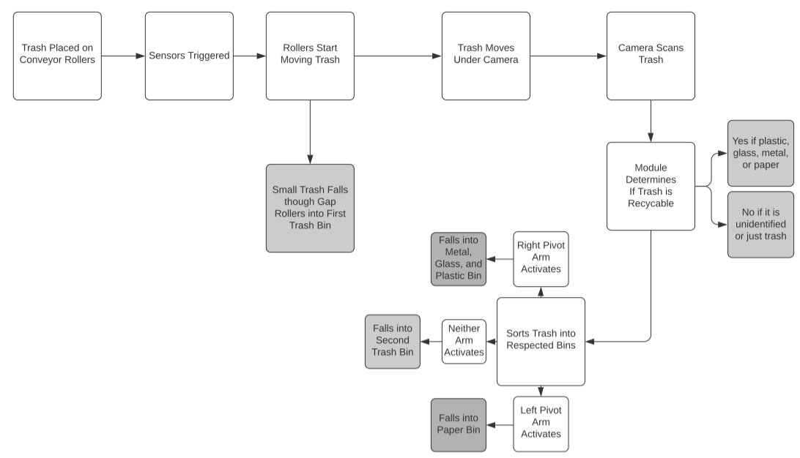

Lab Project Block diagram

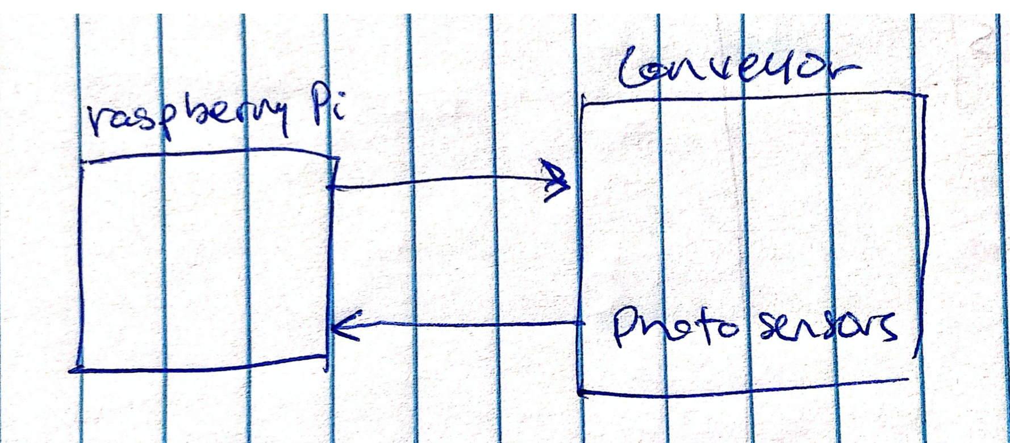

Components

1. Raspberry Pi Development Kits (2)
2. Conveyor Belt Interface
3. Lab Monitors/Kindle Interface
4. USB Connectors
5. Breadboard

Components to be purchased

1. USB connectors
2. Wires?

Member Listing

1. Robert Akinie
2. Heon Soo Park

We would both work on connecting the Raspberry Pi to the Conveyor belt, and making the belt move at different speeds, start and stop, based on input from the machine learning module.